SQL ASSIGNMENT

Submitted By:

G.S.Sameer Basha

Project Trainee, KPI PARTNERS

Email: [gadivemula.basha@kpipartners.com](mailto:gadivemula.basha@kpipartners.com)

**NEW YORK CITY TAXI AND LIMOUSINE COMMISSION**

**TABLE OF CONTENT**

**CHAPTER. 1. INTRODUCTION**

**CHAPETR. 2. A BRIEF DESCRIPTION OF THE DATA USED**

**CHAPETR. 3. QUERIES AND RESULTS**

**CHAPTER 1**

**INTRODUCTION**

The New York City Taxi and Limousine Commission (TLC), created in 1971, is the agency responsible for licensing and regulating New York City's Medallion (green) taxi cabs, for-hire vehicles (community-based liveries, black cars and luxury limousines), commuter vans, and paratransit vehicles. Over 200,000 TLC licensees complete approximately 1,000,000 trips each day.

To operate for hire, drivers must first undergo a background check, have a safe driving record, and complete 24 hours of driver training. TLC-licensed vehicles are inspected for safety and emissions at TLC's Woodside Inspection Facility. It is a priority of the New York City Taxi and Limousine Commission to provide safe, reliable transportation options for all New Yorkers and to recognize and address the needs of our licensees. TLC supports and contributes to city-wide efforts of traffic safety, accessibility and technological improvements. Policy researchers at the TLC use data generated by licenses to observe changing trends in the industry and inform decisions made by agency and the City.

**CHAPTER 2**

**A BRIEF DESCRIPTION OF THE DATA USED**

**VendorID:**

A code indicating the LPEP provider that provided the record. 1= Creative Mobile Technologies, LLC; 2= VeriFone Inc.

**lpep_pickup_datetime:**

The date and time when the meter was engaged.

**lpep_dropoff_datetime:**

The date and time when the meter was disengaged.

**Passenger_count:**

The number of passengers in the vehicle. This is a driver-entered value.

**Trip_distance:**

The elapsed trip distance in miles reported by the taximeter.

**PULocationID:**

TLC Taxi Zone in which the taximeter was engaged.

**DOLocationID:**

TLC Taxi Zone in which the taximeter was disengaged.

**RateCodeID:**

The final rate code in effect at the end of the trip. 1= Standard rate 2=JFK 3=Newark 4=Nassau or Westchester 5=Negotiated fare 6=Group ride.

**Store_and_fwd_flag:**

This flag indicates whether the trip record was held in vehicle memory before sending to the vendor, aka “store and forward,” because the vehicle did not have a connection to the server. Y= store and forward trip, N= not a store and forward trip

**Payment_type:**

A numeric code signifying how the passenger paid for the trip. 1= Credit card 2= Cash 3= No charge 4= Dispute 5= Unknown 6= Voided trip.

**Fare_amount:**

The time-and-distance fare calculated by the meter. Extra Miscellaneous extras and surcharges. Currently, this only includes the $0.50 and $1 rush hour and overnight charges. MTA_tax $0.50 MTA tax that is automatically triggered based on the metered rate in use. Improvement_surcharge $0.30 improvement surcharge assessed on hailed trips at the flag drop. The improvement surcharge began being levied in 2015.

**Tip_amount:**

This field is automatically populated for credit card tips. Cash tips are not included.

**Tolls_amount:**

Total amount of all tolls paid in trip.

**Total_amount:**

The total amount charged to passengers. Does not include cash tips.

**Trip_type:**

A code indicating whether the trip was a street-hail or a dispatch that is automatically assigned based on the metered rate in use but can be altered by the driver. 1= Street-hail 2= Dispatch

In this analysis for storage and querying the green taxi trip data accumulated for the year 2019, we have used the following

**CHAPETR. 3**

**QUERIES AND RESULTS**

**Create the table structure with appropriate data types before loading data**

create table green_tr

(

"VendorID" float,

lpep_pickup_datetime varchar2(40),

lpep_dropoff_datetime varchar2(40),

store_and_fwd_flag varchar2(1) default 'N',

"RatecodeID" float,

"PULocationID" float,

"DOLocationID" float,

passenger_count float,

trip_distance float,

fare_amount float,

extra float,

mta_tax float,

tip_amount float,

tolls_amount float,

ehail_fee float ,

improvement_surcharge float,

total_amount float,

payment_type float,

trip_type float,

congestion_surcharge float

);

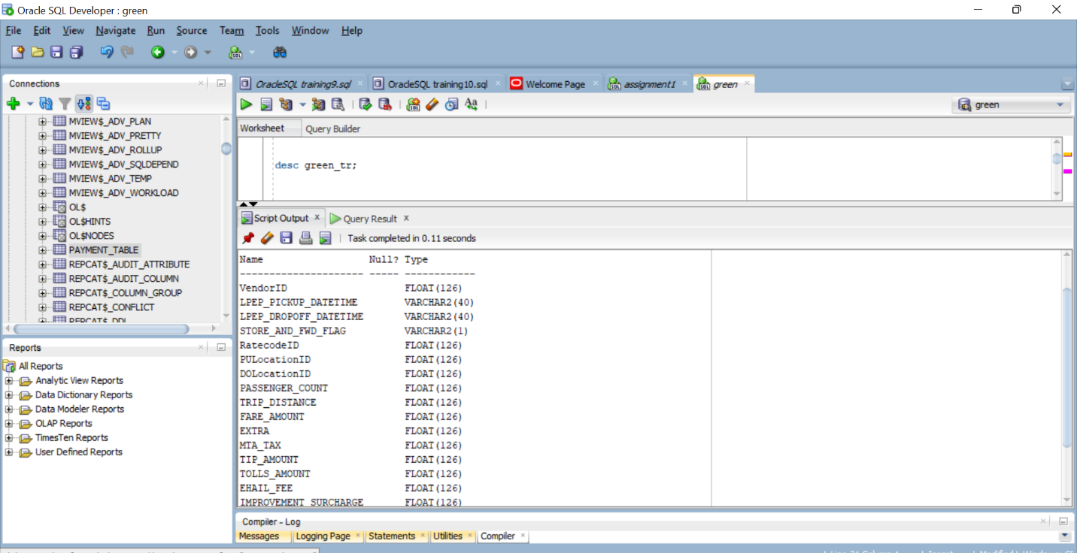

select count(*) from green_tr;

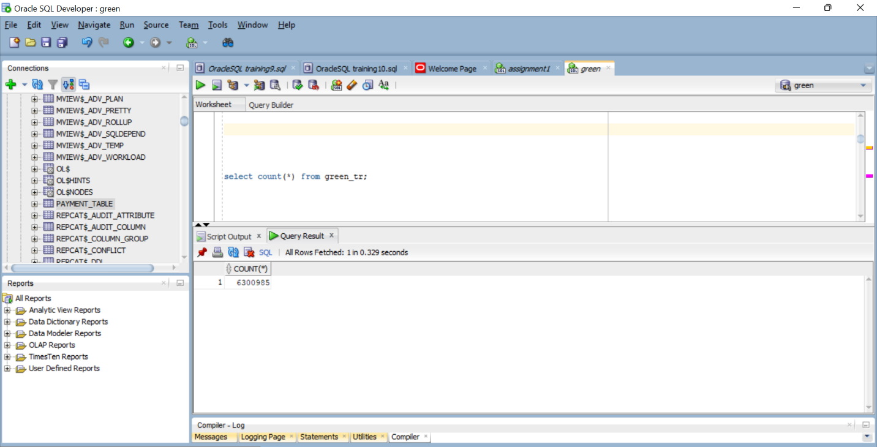

CREATE TABLE taxi_lookup1

(

"LocationID" NUMBER primary key,

"Borough" VARCHAR2(20),

"Zones" VARCHAR2(50),

service_zone VARCHAR2(20)

);

Desc taxi_lookup1;

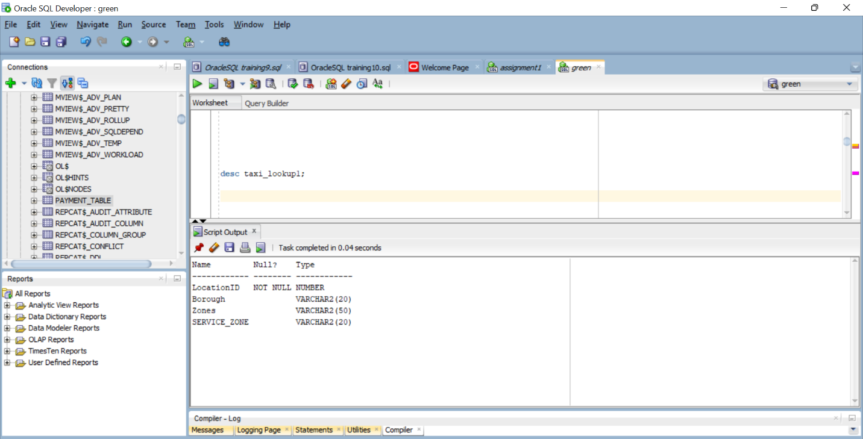

select * from taxi_lookup1;

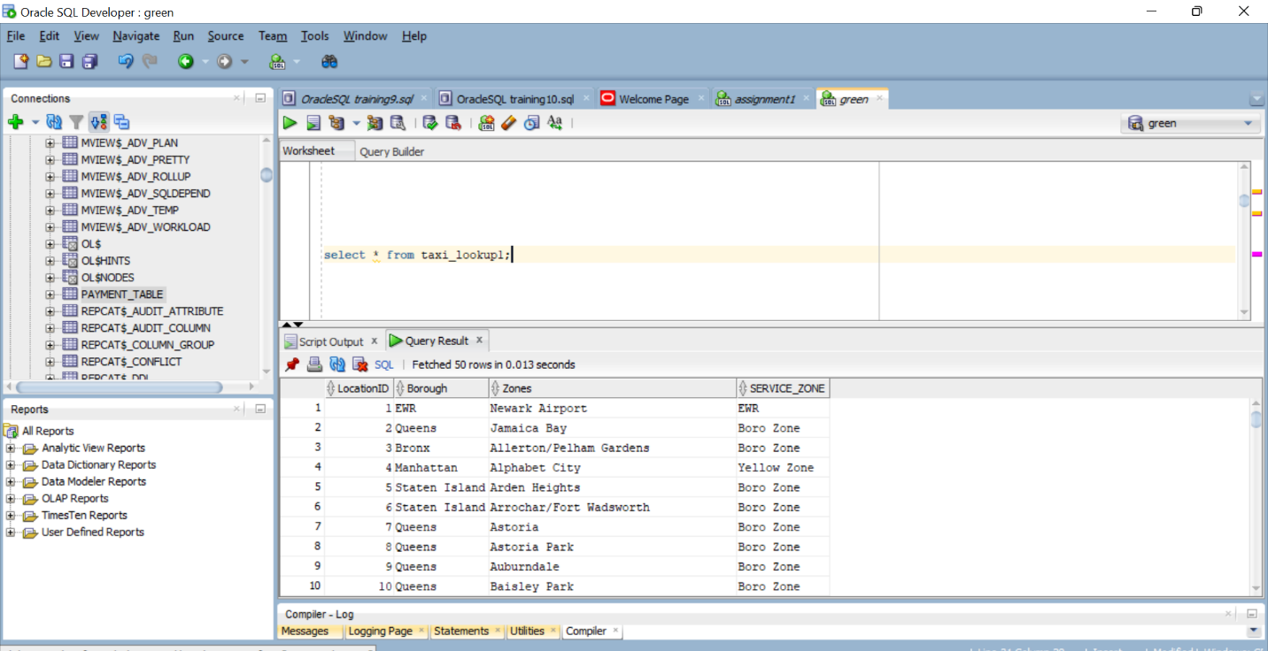

create table payment_table(payment_type number(2), payment_name varchar2(30));

select * from payment_table;

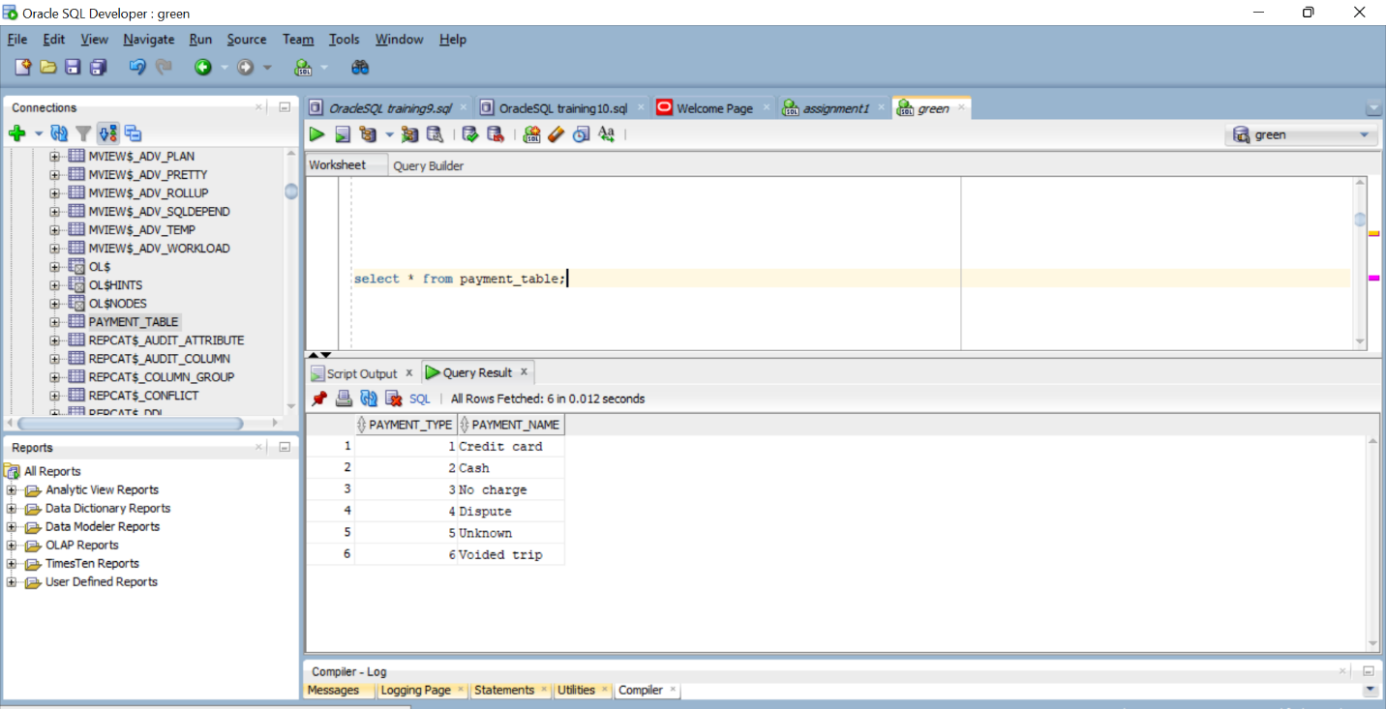

**Reading the csv file using pandas and storing in a variable and exporting the read data to oracle database using sqlalchemy module.**

1. Use python to load the all the 2019 files to an Oracle Database table

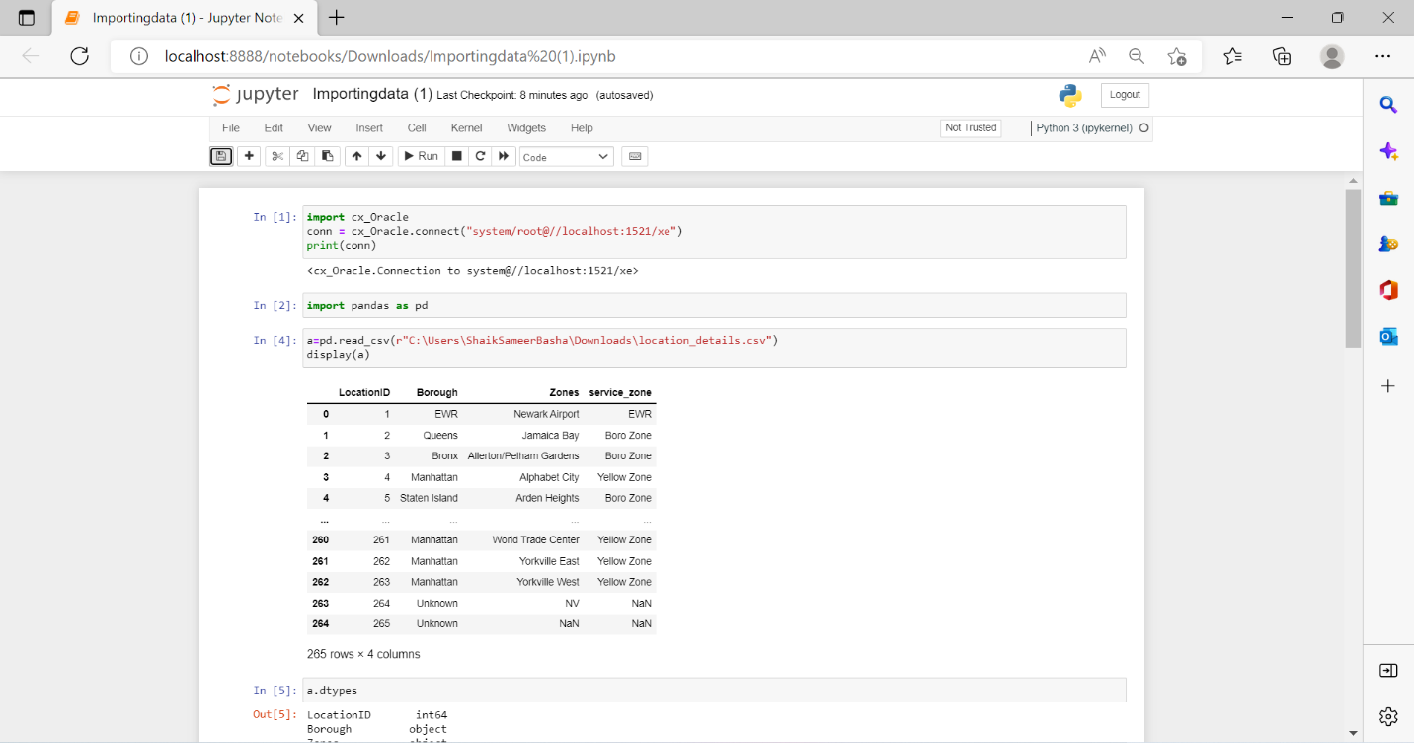

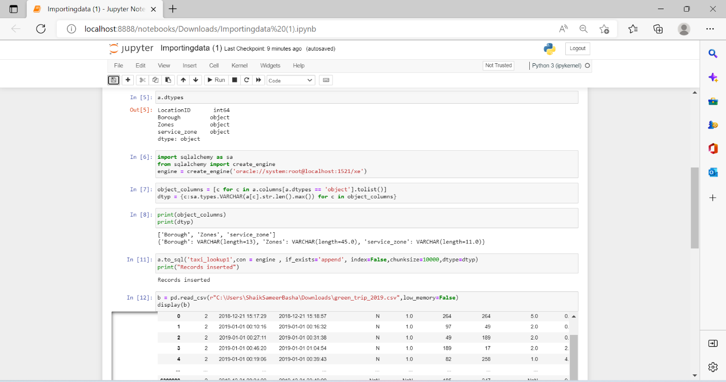

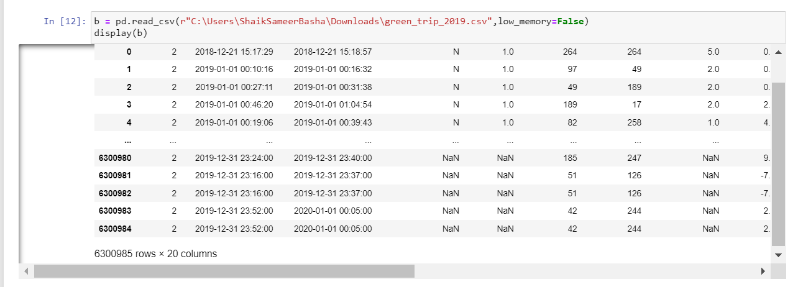

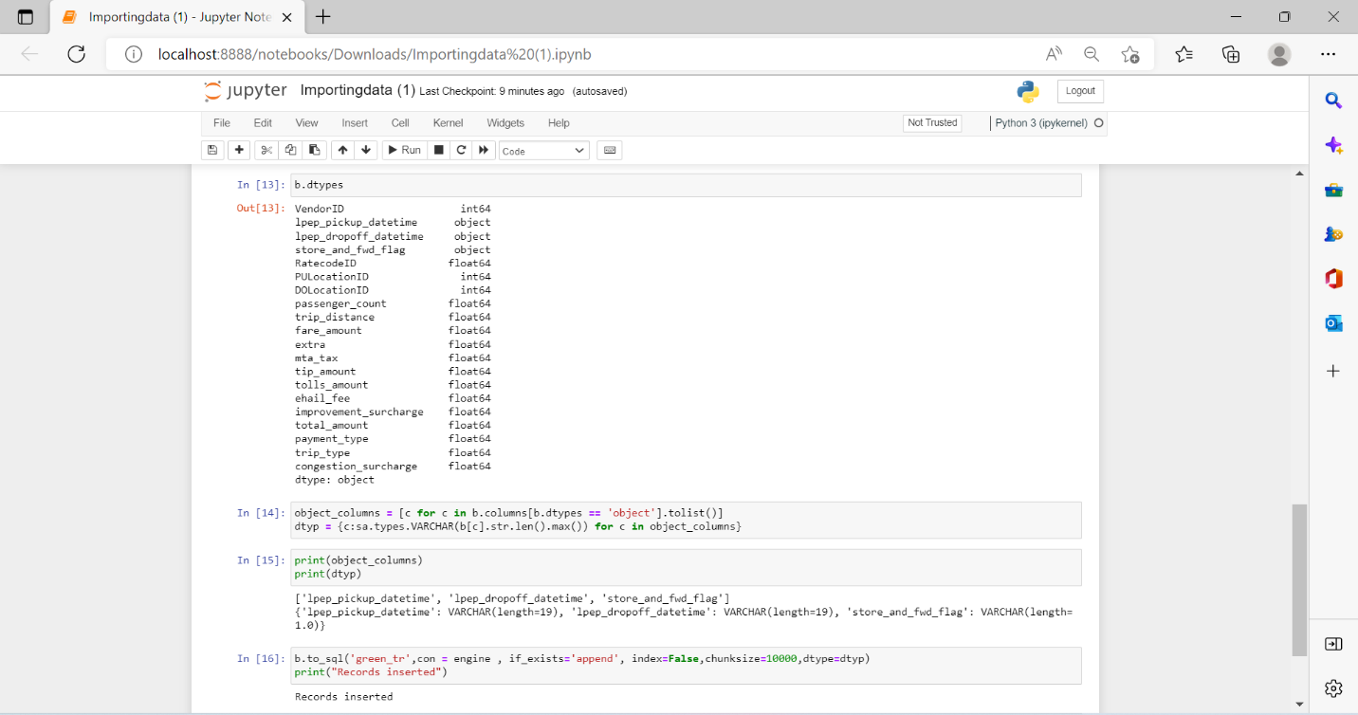

**QUERIES**

A) Find the month wise trip count, average distance and average passenger count from the trips completed by green taxis in 2019.

select count(lpep_pickup_datetime) as trip_count,avg(trip_distance) as avg_distance,

avg(passenger_count) as avg_passenger_count

from green_tr;

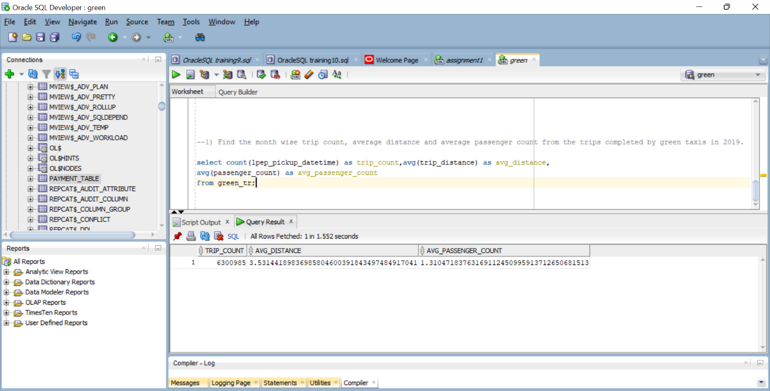

B) Find out the five busiest routes served by the green taxis during 2019. The name of start and drop points to be provided.

select * from

(

with TripT as

(

select TL1."Zones" || ',' || TL1."Borough" as "Pick Point", TL2."Zones" || ',' || TL2."Borough" as "Drop Point"

from green_tr

inner join taxi_lookup1 TL1 on TL1."LocationID" =green_tr."PULocationID"

inner join taxi_lookup1 TL2 on TL2."LocationID"=green_tr."DOLocationID"

)

select "Pick Point","Drop Point",count(*) cnt from TripT

group by "Pick Point","Drop Point" order by cnt desc

)

where rownum<=5

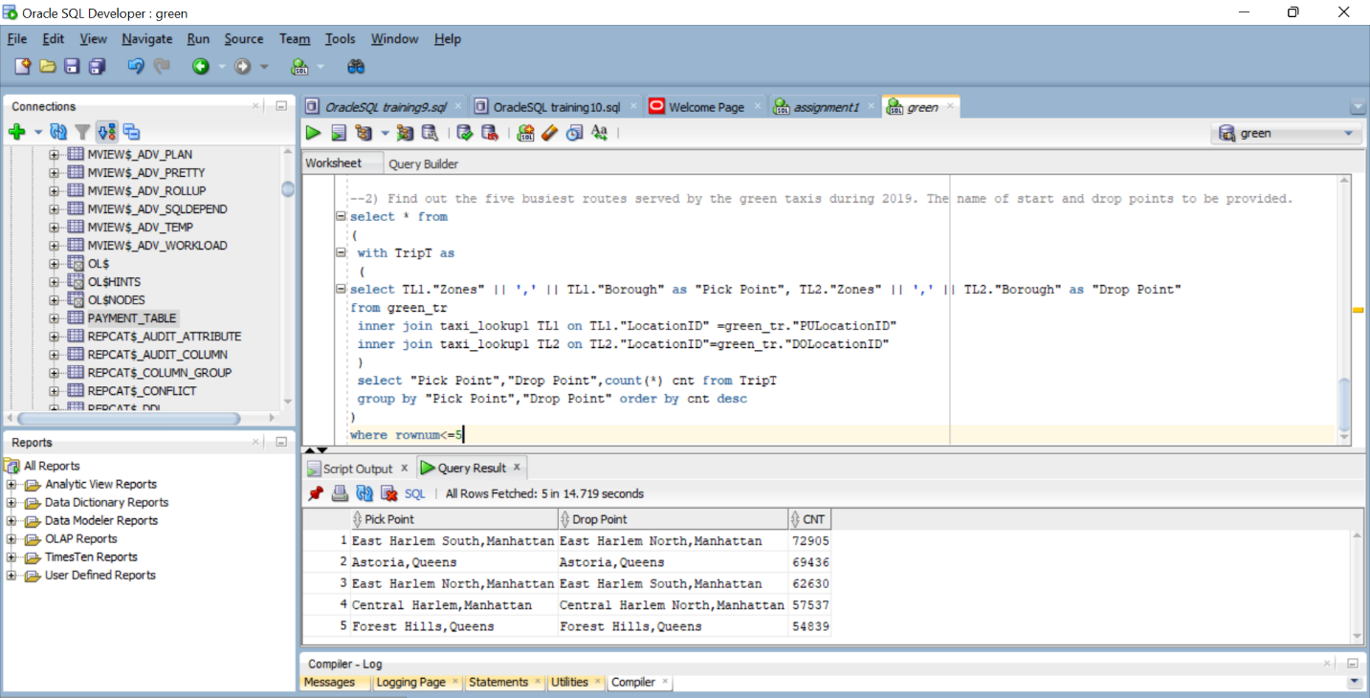

C) What are the top 3 busiest hours of the day for the taxis?

SELECT Hours AS busiest_hour, pickup_count

FROM

(SELECT

EXTRACT(HOUR FROM TO_TIMESTAMP(lpep_pickup_datetime, 'YYYY-MM-DD HH24:MI:SS')) AS Hours,

COUNT(*) AS pickup_count

FROM green_tr

GROUP BY EXTRACT(HOUR FROM TO_TIMESTAMP(lpep_pickup_datetime, 'YYYY-MM-DD HH24:MI:SS'))

ORDER BY pickup_count DESC)

WHERE ROWNUM<=3;

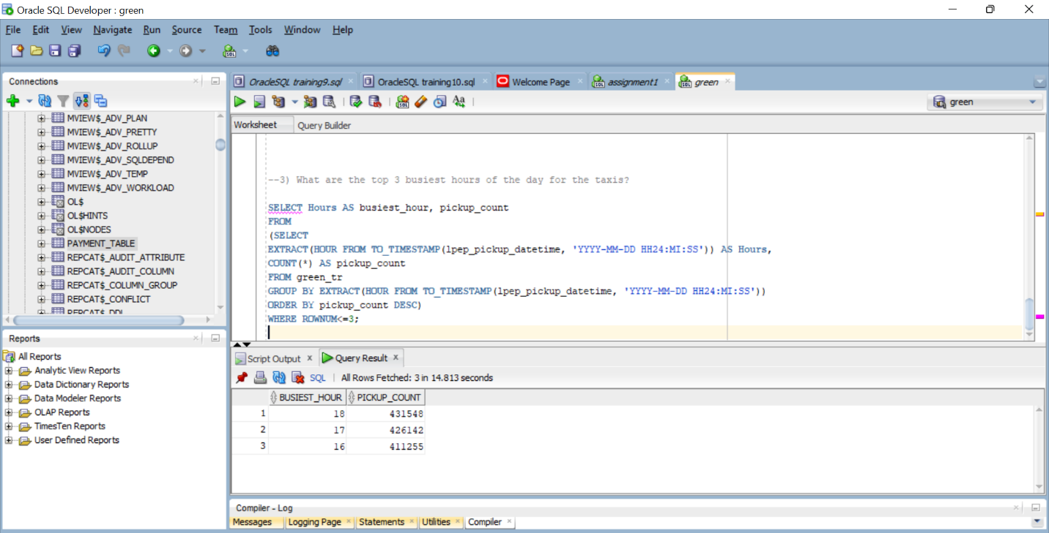

D) What is the most preferred way of payment used by the passengers?

SELECT payment_name AS Most_Preferred_Way_Of_Payment FROM Payment_table

WHERE payment_type IN (SELECT payment_type FROM green_tr HAVING

COUNT(payment_type) IN (SELECT MAX(COUNT(payment_type)) FROM green_tr

GROUP BY payment_type) GROUP BY payment_type);

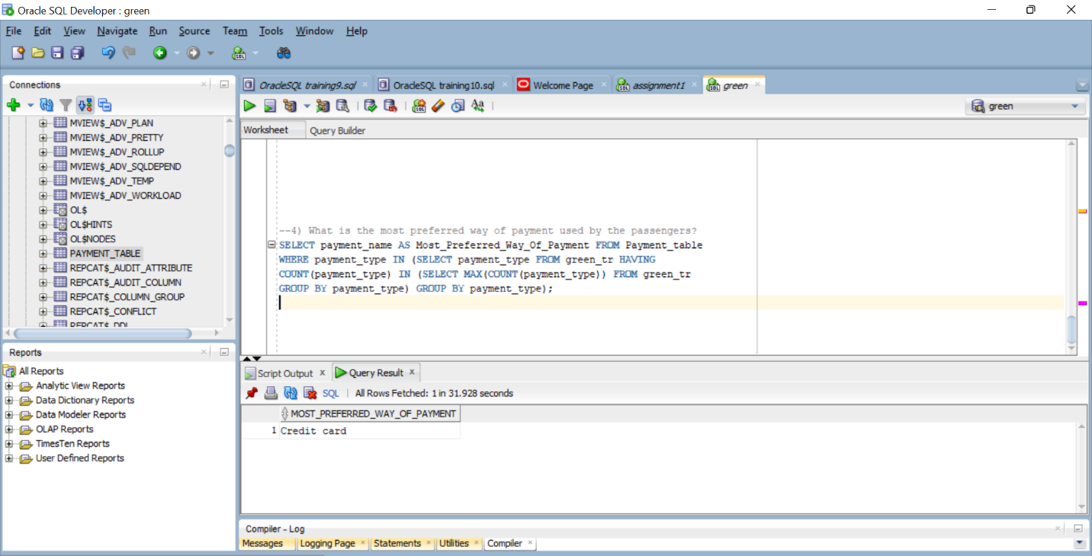

E) Write a PL/SQL block to read through each record and update ehail_fee to 0.5 (capture the time taken for execution)

create or replace procedure Update_ehail_fee

is

begin

update green_tr set ehail_fee= 0.5;

end;

begin

Update_ehail_fee;

end;

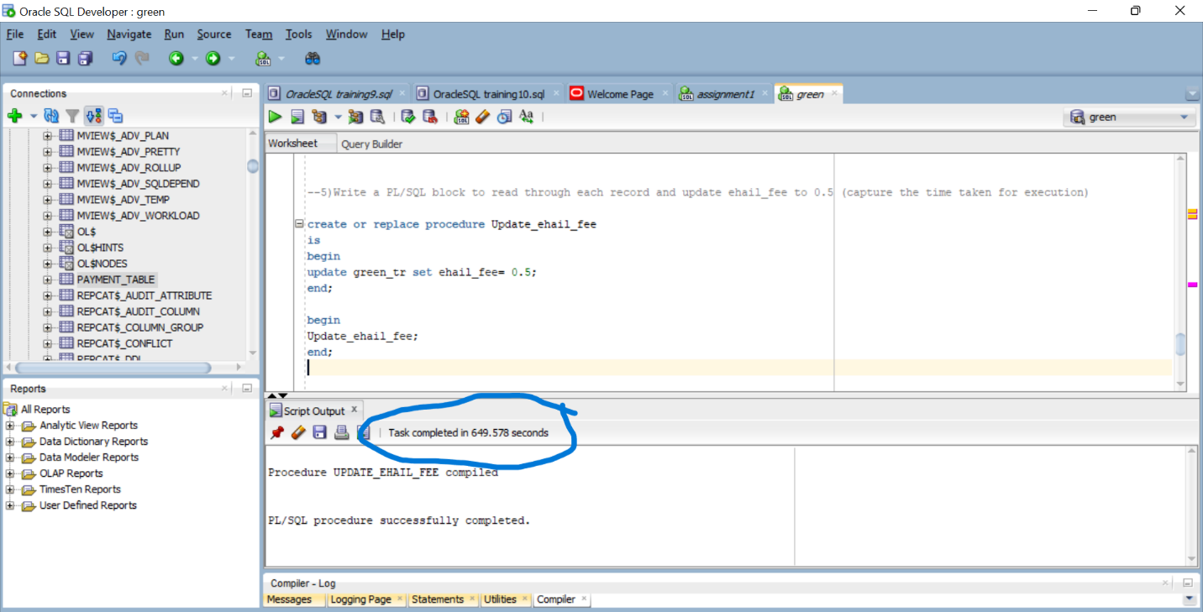

select ehail_fee from green_tr;

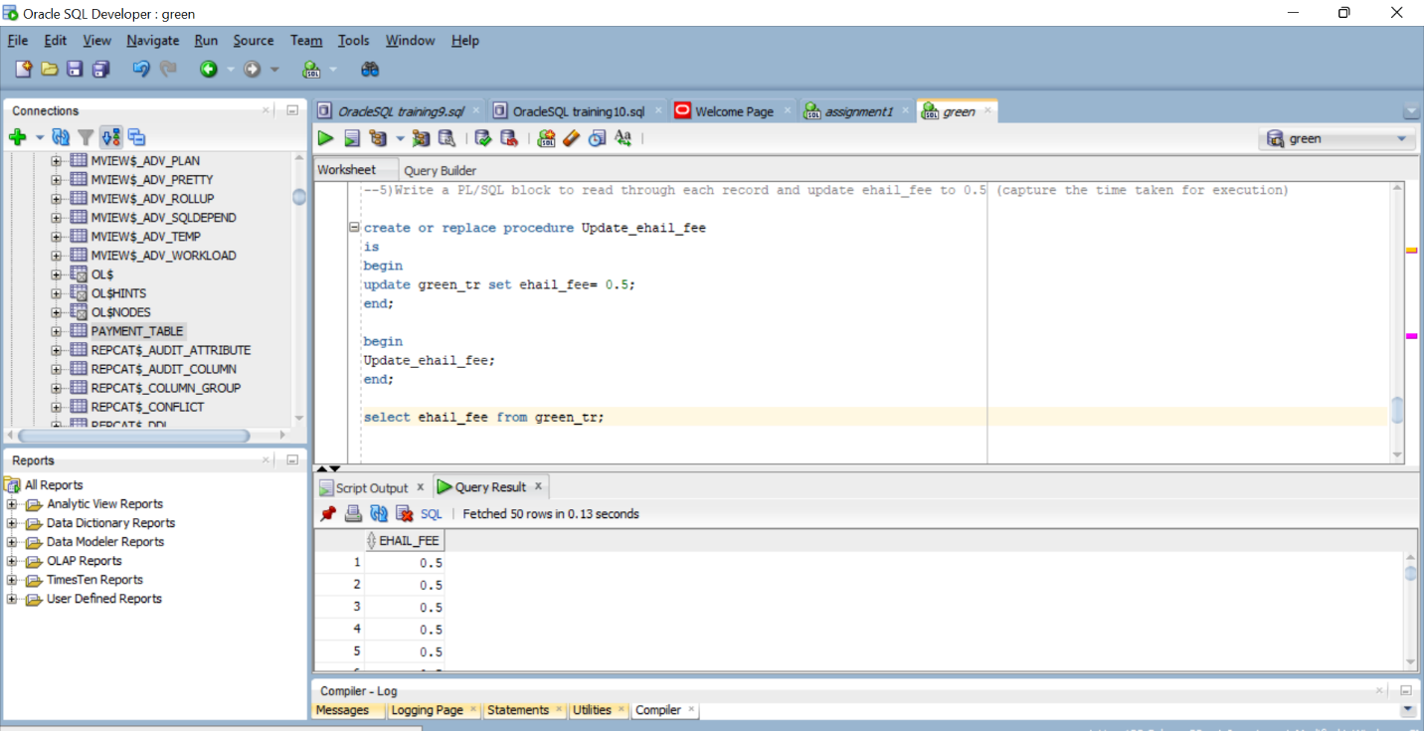

F) Write a normal update statement to update ehail_fee to 0.75

update green_tr set ehail_fee= 0.75;

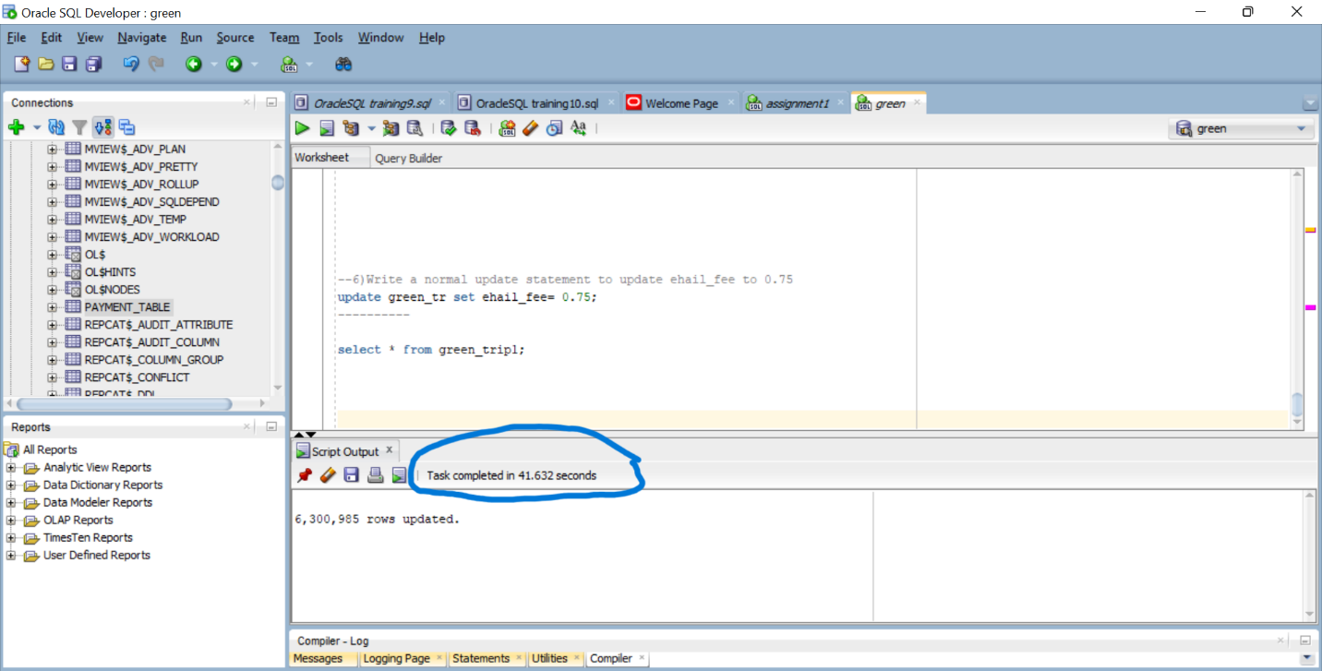

select ehail_fee from green_tr;

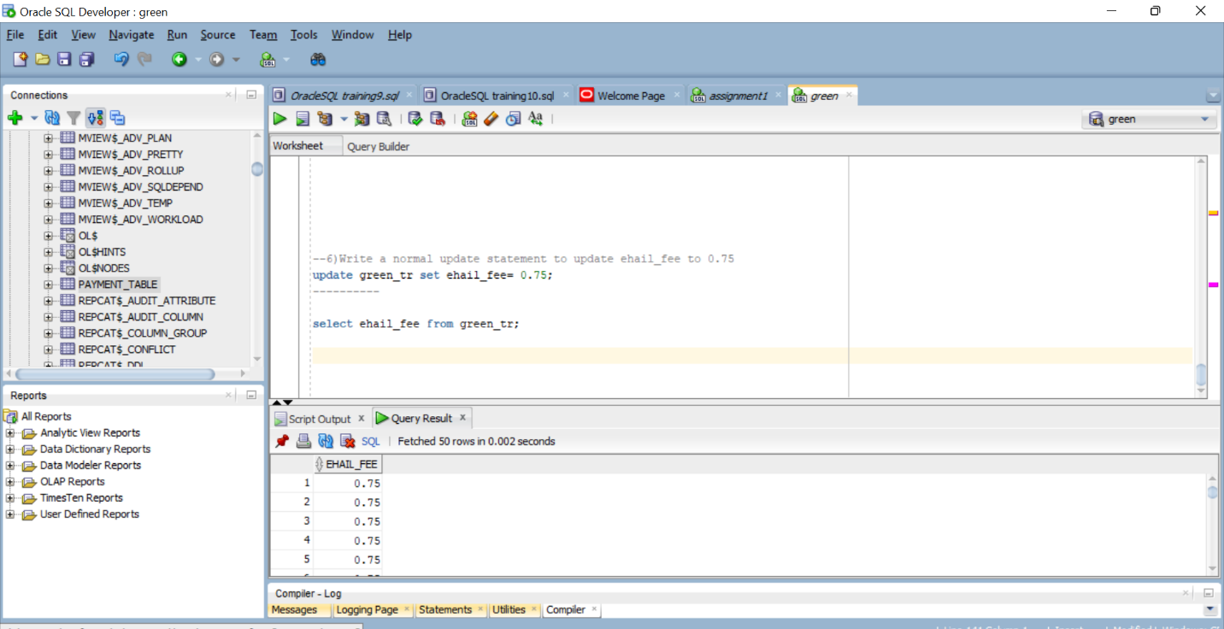

1. Identify the time taken by e and f and provide your analysis on why each step took more/less time compared to other

Both E & F updated 63,00,985 records separately. Time taken by E is 649.578 Seconds

Where F took 41.632 seconds.

When we compare the time taken by E & F. E is Too slow & F is faster.

E consists the procedure which stored in the sql server takes much time to execute.

While F with normal sql update statement took less time